 | Standard Operating Procedures Best Practices for Inventory Reporting & Tools

Desktop Reporting:
This reporting tool allows managers to generate a wide range of reports through use of report selection criteria.

- Navigate to the Reporting – Report Selector Page through the menu.  - The ‘Report Selector’ screen will appear. | 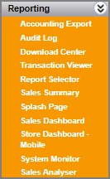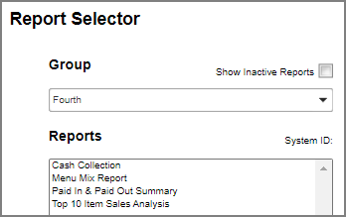  2  1
- From the Group category dropdown, select the required report group.  - From the list of reports, select one of the reports to generate. | 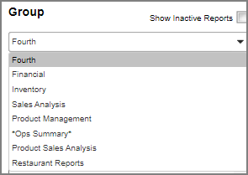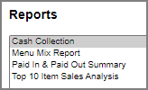  4  3
- Select the dates based on the calendar/period options available for that report.  - Select the report format type from the drop-down options. Reports input selections vary by reports.  - Click the ‘Generate’ button to create the selected report. Some reports will be sent to Download Center in order to retrieve the reports. | 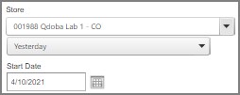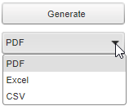  7  6  5
- Navigate to the Reporting – Download Center Page through the menu. | 8
- Once the report is listed in the Download Centre main panel, you can choose to download it, delete it or email it. | 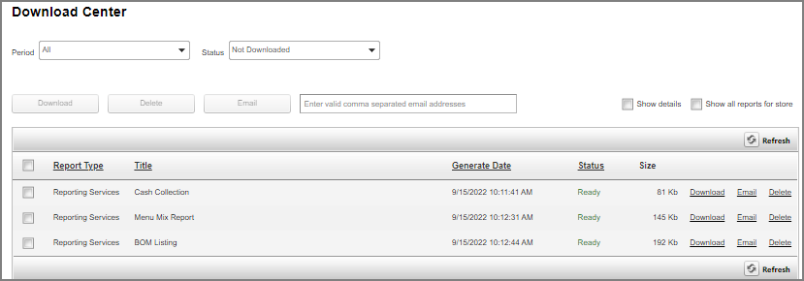  9

Splash Page:

Splash Page Functions
A message can appear on the landing page after you log in to Fourth, this is called the Splash Page. It is used to inform users of news, updates and alerts from their Head Office.

- A message can appear on the landing page after you log in to Fourth, this is called the Splash Page. It is used to inform users of news, updates, and alerts from their Head Office. | 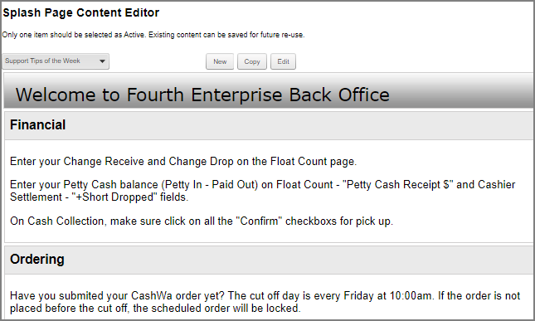  1
- Once the message is read, you have two options:  - Select ‘Continue’ to close the Splash page and move on to other areas of MX.  - Select this checkbox to not see the page again until it changes.  - You can always find the Splash Page message under the Menu tab, Reporting – Splash Page. | 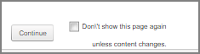  2  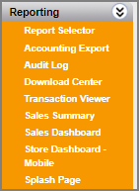  3

