 | Standard Operating Procedures Best Practices for Inventory Stock Count

Stock Count Tasks:

Weekly Stock Counts should be performed weekly using a mobile device.

Spot/Daily Counts can be conducted on a few select number of high risk or high value items.
- Navigate to the Counts – Weekly Count Page through the menu.  - The Weekly Count locations and inventory items will appear. | 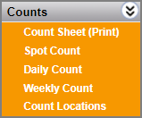  1  2  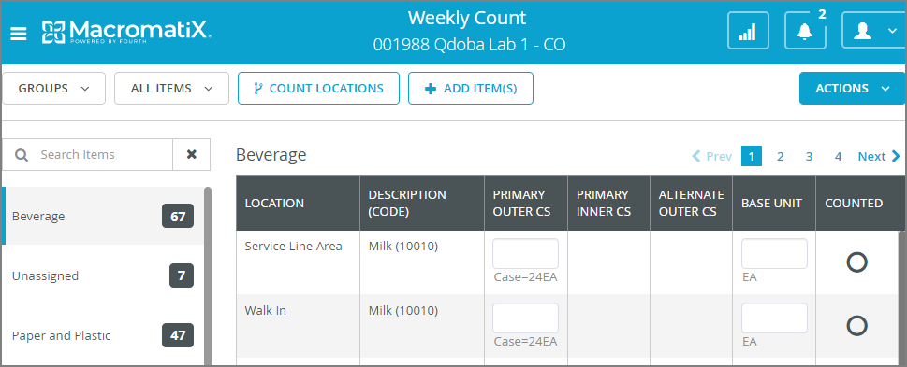
- If there is already an opened count for that type (Weekly, Daily, Spot) more than two days, you will see the ‘Delete Count’ pop-up to continue the existing count or delete and start a new one.  Select ‘DELETE’ or ‘CANCEL’ to start or continue the count. | 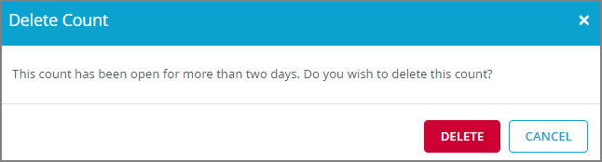  3
- On the Mobile Inventory Count menu an icon may appear next to the count types:  This icon means that this stock count is in progress. | 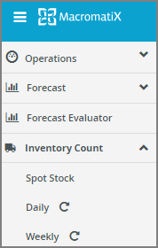  4
- On the left panel you will see a list of stock locations with the total amount of inventory items stored there.  The number inside the black square indicates how many items are still to be counted in that location. | 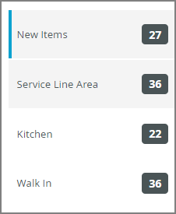  5
- Navigate to each location to count inventory items within it.  - The ‘COUNTED’ column is default to a black circle until it’s counted then it will turn to an orange check circle. | 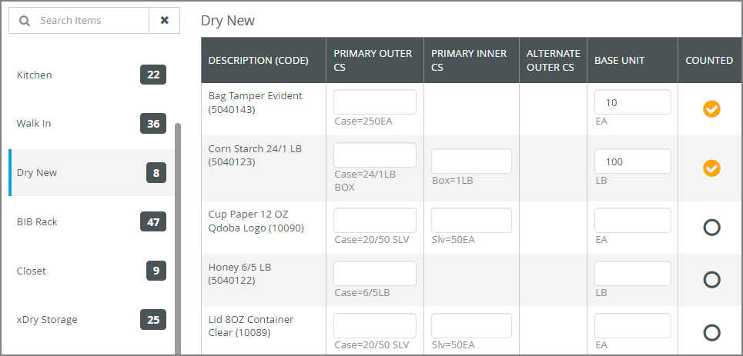  7  6
- Once all items are count in the location (Kitchen, Walk In, Dry…) , the number next to the location name will become 0 and the color will become orange.  Please be aware of using 0:  - Entering a 0 means there is 0 amount left of this item.  - Leaving the field blank means you have not counted this item yet. | 8  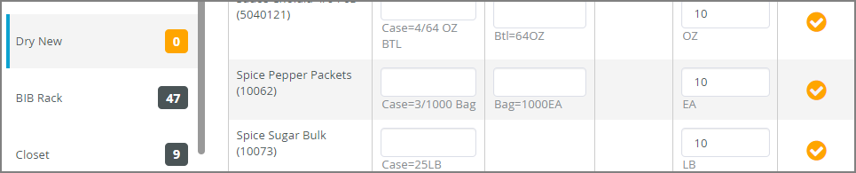
- Once you have counted all items, click on the tab on the top right-hand side.  - Select one of the following 4 options: Submit: This action will show you a summary of the count. You can choose the apply date and time and finalise the count by clicking ‘SUBMIT COUNT’. | 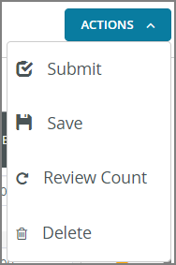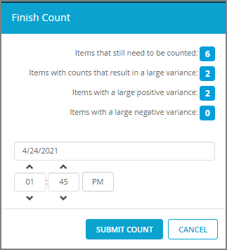  10  9  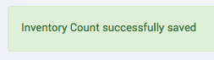
- Save: If you wish to finish the count later, this will save the amounts you have already entered for this count.  - Review Count: The review count shows you the inventory values in a summary prior to applying the count to the system. This provides you with a sanity check before submitting the count.  - Delete: If this option is chosen a confirmation box will appear and you can select to delete the count and it will not be applied. | 13  12  11
- If you want to count an item but don’t know where the location is, on the ‘Search Item’ field begin to type an item name, any items with those letters in it will appear.  - Select the requested item from the search suggestions.  - By selecting the location, you will see that specific item appear in the main panel for counting. | 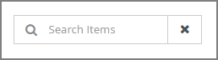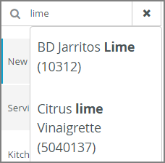  15  14  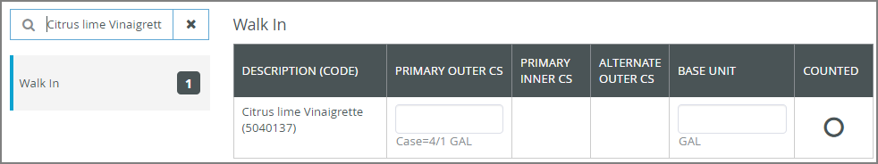  16
- To return to the count, click on the search field and the count will appear again. | 17  