|  |  |
| --- | --- |
|  | ***Standard Operating Procedures Best Practices for Cash Management*** |

|  |
| --- |
|  |

# Cash Management Tasks:

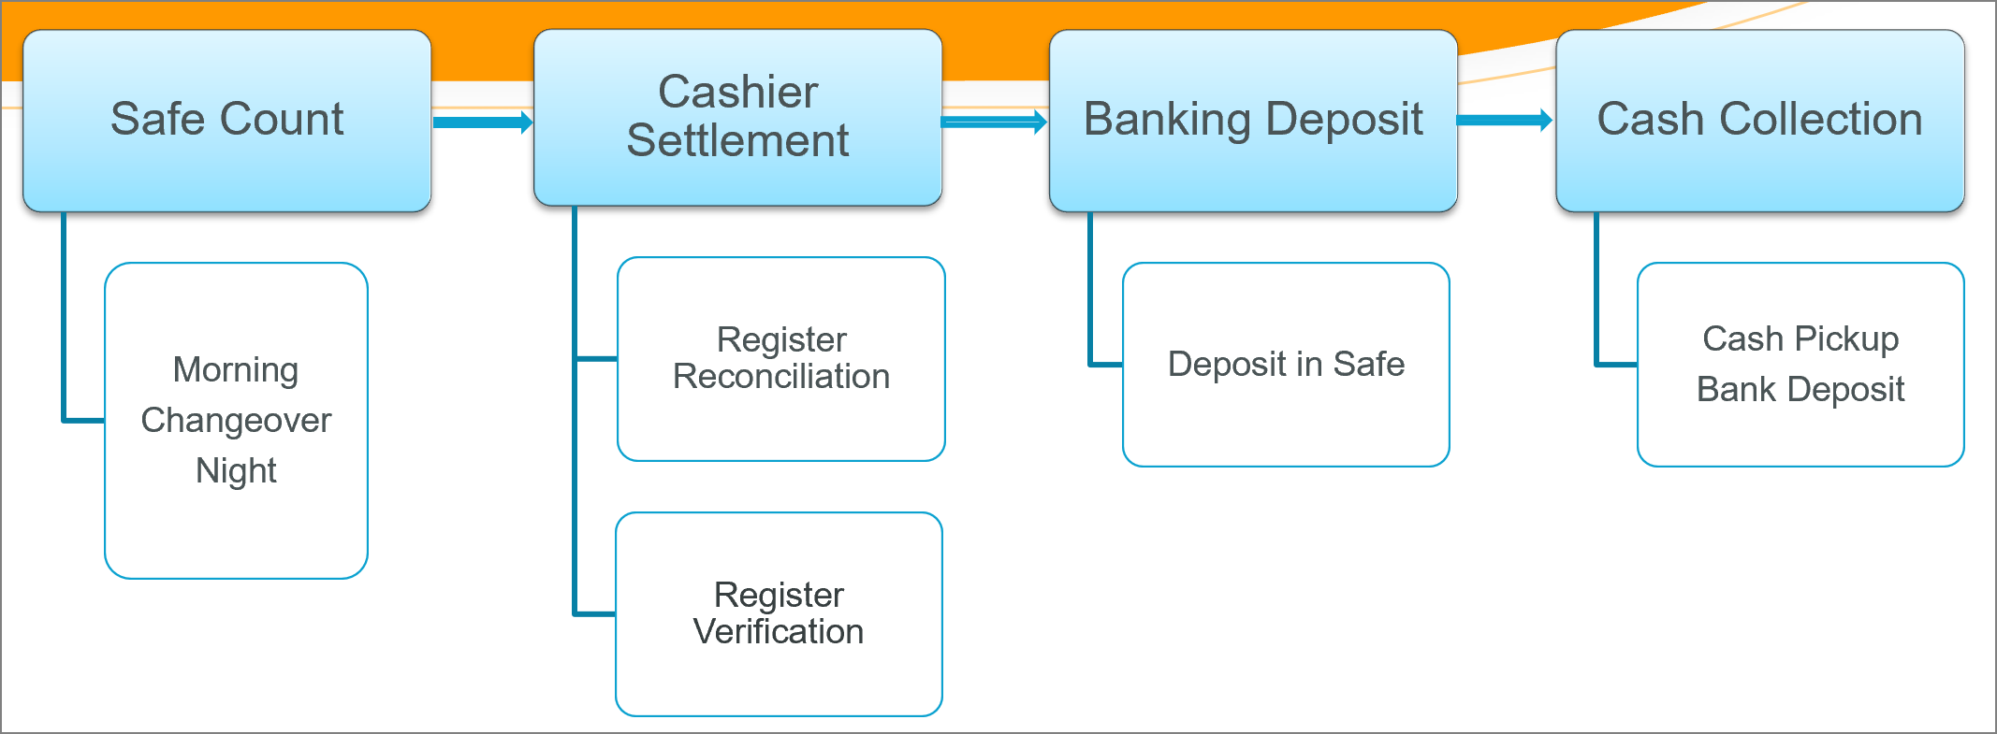

## Safe Count Steps

|  |  |
| --- | --- |
| 1. Navigate to the **Financial – Safe Count** Page through the menu. 2. Ensure that the correct store and date are selected. The date will default to your current day in all pages of the application. | 2  1 |
| 1. Enter the ‘Coins’ and ‘Bills’, the total amount in safe. Enter ‘Money in Registers’, the total amount in registers. The system will calculate the total amounts in the ‘Total Count $’ field. ‘Store Safe Total $’ is the pre-set default safe amount configured for the store. 2. The ‘Total Count $’ should equal to ‘Store Safe Total $’ to make $0.00 variance. 3. Authorize the Safe Count by clicking the Authorize button. A confirmation pop-up will appear once authorized. | 4  3    5 |
| 1. If there is a variance, an explanation in the ‘comments’ field will be compulsory. 2. Else you will be prompted the Error pop-up window when you try to authorize.   An email notification alert will send to store and district managers if the variance exceeded the pre-set threshold. | 7  6 |

# Cashier Settlement Tasks:

## Settle & Close Cashier Steps

Cashier Settlements include all the necessary data, for a particular register, after the register has closed out at the point of sale. Best practice is to perform cashier settlement immediately after they log out of the POS to keep track of variances instantly.

|  |  |
| --- | --- |
| 1. Navigate to the **Financial – Cashier Settlement** Page through the menu.   The system will default to the current day. If you need to review a previous day select the relevant week and date from the drop-down list. | 1 |
| 1. From the ‘Reconciliation’ drop-down list, select the Cashier Close you are counting.   Orange is for the registers that already closed in POS but need to do be closed at Fourth. | 2 |
| 1. Select the authorizer in the ‘Manager Name’ drop down list. 2. In the panel labelled ‘Step 2 – Total Register Count’ enter the total cash amount. 3. Select the Authorize button to authorize the cashier close cash count.   **NOTE:** When you count cash, you should EXCLUDE the register float amount of $250 or so and any cash tip payout.  Here you are only counting the money that will go to the safe. | 5  4  3 |
| 1. The system will check that the amount you have entered *matches the sales amount expected*. | 6 |
| 1. An email notification alert will send to store and district managers if the variance exceeded the pre-set threshold. | 7 |
| 1. You will then be re-directed to the  tab to review the totals.   This section displays the many different forms of payment that were processed from this register and will show the expected sales cash amount that should now be deposited in the safe. | 8 |
| 1. If there is cash tip payout enter the amount in the **Tips Cash Payout** field.   The Tips Cash Payout should equal “Tips Collected” which is calculated by the system. | 9 |
| 1. When you select the next Cashier Close, you will notice that authorized cashier closes will now be showing in Green.   Unauthorized Cashier Closes will be showing in Orange. | 10 |
| 1. If cashiers are still open in POS, they will appear in the list as PURPLE but you can’t access them until they are closed at the point of sales.   You will see the red warning message to state that when you try to access this type of cashiers. | 11 |
| 1. One more thing to be noted, after the authorization if there is a mistake, you can select the “Release & Modify” button to un-authorize and start over again. | 12 |

# Banking Deposit Tasks:

## Banking Deposit Steps

Ensure all Cashier Settlements are authorized.

Ensure all Cash Deposits have been deposited in the safe and processed.

The Banking Summary authorization should be done once at the end of the day.

|  |  |
| --- | --- |
| 1. Navigate to the **Financial – Banking Deposit** Page through the menu.   The system will default to the current day. If you need to review a previous day select the relevant week and date from the drop-down list. | 1 |
| 1. On the ‘Banking Deposit’ tab, you will see 3 fields showing you the following amounts:   **Total of Cashier Deposit:** The total cash amount that has been processed from the authorised Cashier Settlement’s, up to the current time of day.  **Amount Available:** The total cash amount that is available to deposit into the safe.  **Amount Dropped:** The total cash amount that has been deposited into the safe today. | 2 |
| 1. **Drop Amount:** Enter the amount of cash you are about to deposit in the safe.   **Receipt No:** Enter the envelope/bag number that you are placing the cash in. These can’t be the same number during the same day.   1. Select ‘Confirm Drop’. You will then see the bank deposit listed in the top panel of this screen. | 4  3 |
| 1. Select ‘Confirm Drop’. You will then see the bank deposit listed in the top panel of this screen. | 7  6 |
| 1. This screen allows the store manager the opportunity to review the summary of the day’s financial transactions and to complete important tasks before closing the restaurant business day: | 6 |
| 1. The Banking Summary tab displays the deposit total plus consolidated information of financial data for the day including (but, not limited to):  * Credit cards * Gift Cards * Transfers * Checks * Paid in/out * Register sales * Voids * Sales, Promotions * Discounts * Deposit Total * Tips  1. Key indicators to show the summary of different financial types. | Table  Description automatically generated  7  8 |
| 1. Review the Cashier Summary in ‘Step 4 – Cashier Summary’.   This is a list of the Cashier Settlement’s. If all cashiers are showing highlighted in **green**, you can continue.   1. If you see this message please go back to your Cashier Settlement task and complete the cashiers that are not authorized yet. | 9    10 |
| 1. If there is a Cash Short/ Over amount that is above your acceptable business threshold you will need to enter in a Variance Explanation.   An email notification alert will be sent to store and district managers.  If there is a significant variance, first ensure that:   * All settlement’s have been closed and authorized. * All sales cash has been recorded as deposits and authorized.  1. Click on the Authorize button to authorize and close banking for the day. | 12  11 |

# Cash Collection Tasks:

## Cash Collection Steps

|  |  |
| --- | --- |
| 1. Navigate to the **Financial – Cash Collection** Page through the menu.   The system will default to your store or just the drop-down list to select the store. | 1 |
| 1. you will see a list of deposits that have not been collected yet. 2. Next to each deposit you check the ‘Confirm’ box to show the deposit was deposited in the bank. | 3  2 |
| 1. In the ‘Receipt Number’ field, enter the reference number from the bank receipt or any number to refer this deposit.   This field is not required, and it’s not used anywhere in the system but its recommended. | 4 |
| 1. The Manager must enter their Username and Password and click ‘Authorize’. | 5 |