# Safe Count

Counting the contents of the store safe and recording the amount in Fourth.

How to enter a Safe Count

**Step 1.** From the Work Flow, select the ‘Morning Safe Count’, ‘Changeover Safe Count’ or ‘Night Safe Count’ task

**Step 2.** Or from the Menu tab, navigate to the Financial – Safe Count Page. There are three Safe Counts daily.



**2**



**1**

**Step 3.** Ensure that the correct store and date are selected. The date will default to your current day in all pages of the application.

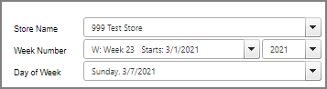

**3**

**Step 4.** Enter ‘Coins’, the total amount in safe.

**Step 5.** Enter ‘Money in Registers’, the total amount in registers. The system will calculate the total amounts in ‘Total Count $’. ‘Store Safe Total $’ is the pre-set default safe amount configured for the store. It’s default to $1,250’, $1,000 or $1,500. ‘Total Count $’ should equal to ‘Store Safe Total $’ to make $0.00 variance.

**Step 6.** The variance threshold is set to $1.50, if it exceeds the threshold, an email notification will be sent to district managers and you will need to enter the reason in the Comments field to authorize.

**Step 7.** Click ‘Authorize’, a confirmation pop-up will appear once authorised.

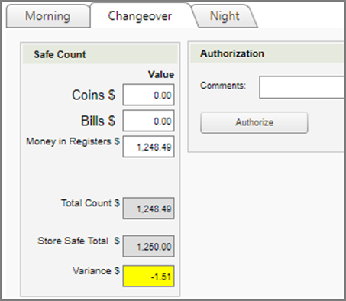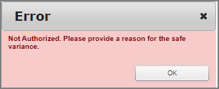

**7**

**4**

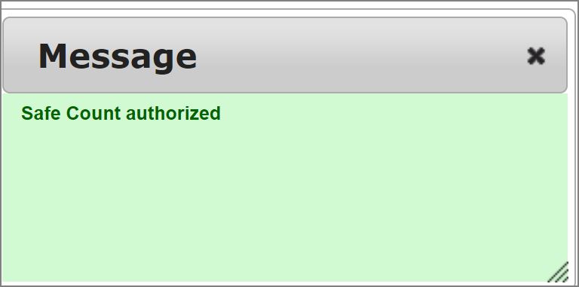

**7**

**6**

**5**

# Cashier Settlement

Count down the cashier’s register immediately after they log out of the POS.

How to complete a Cashier Settlement

**Step 1.** From the Work Flow, select the ‘Cashier Settlement’ task

**Step 2.** Or from the Menu tab, navigate to the Financial – Cashier Settlement Page.

 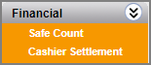

**2**

**1**

**Step 3.** The system will default to the current day. If you need to review a previous day select the relevant week and date from the drop-down list.

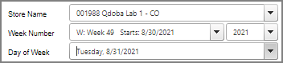

**3**

**Step 4.** From the ‘Reconciliation’ drop-down list, select the Cashier Close you are counting.

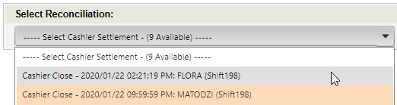 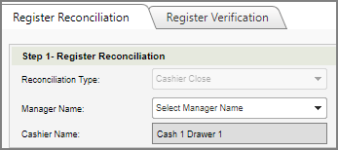

**5**

**4**

**Step 5.** Select the manager from the ‘Manager Name’ drop down list.

**Step 6.** In the panel labelled ‘Step 2 – Total Drawer Deposit’ enter the total amount of cash that was in the register. Enter ‘Bills $’ only since the store don’t count coins.

The amount entered should **EXCLUDE** **cash tip payouts** and **register drawer amount of $250**. Select ‘Update’ to update ‘Total Cash To Deposit $’.

**THE BILLS ENTERED SHOULD BE THE CASH TO DEPOSIT AFTER COUNTING DOWN THE DRAWER.**

**Step 7.** The Manager click ‘Authorize’.

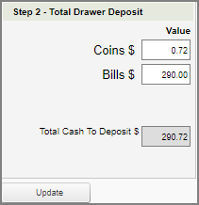 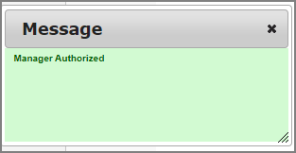

**7**

**6**

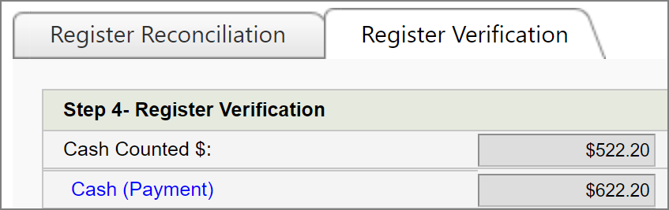**Step 8.** You will then be re-directed to the  tab to review the totals. This section displays the many different forms of payment that were processed from this register and will show the expected sales cash amount that should now be deposited in the safe.

**9**

**8**

**Step 9.** ‘Cash (Payment)’ is the amount that the system expects and ‘Cash Counted $’ is what you entered and authorized.

**Step 10.** Enter the tips paid out in ‘+ Tips Cash Payout’ but the tendered tips will show $0.00 for Monkey Media tips. This is because the tip is assigned to the virtual cashier for Monkey Media orders. Store should add up the tips paid out from their day shift Monkey Media orders that have been pushed to the POS + any tips tendered section. This would only apply for catering orders that were paid at register and paid with credit card with tip.

‘Tip Collected’ shows how much cash tip the system expects. ‘Tip Collected’ should equal to ‘+Tips Cash Payout’.

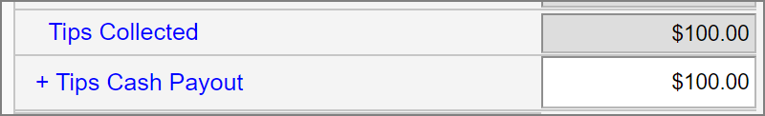 

**10**

**Step 11.** After authorized the cash count and enter the cash tip (if any), ‘= Cash Short $’ will show the variance. The variance threshold is set to +/-$10. If it exceeds the threshold, you must enter ‘Variance Explanation’ in order to authorize. An email notification will be sent to district managers.

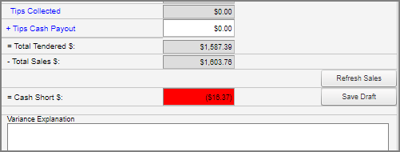

**11**

**Step 12.** If there is no variance, ‘= Cash Over/Short’ will be green with no ‘Variance Explanation’ box visible.



**12**

**Step 13.** Click  after review and confirm.

**NOTE:** When you select the next Cashier Close, you will notice that authorized cashier closes will now be showing in **Green**. Unauthorized Cashier Closes will be showing in **Orange**.

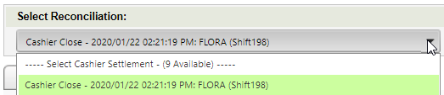

NOTE: If cashiers are still open in POS, they will appear in the list but can’t access until they are closed in POS. You are not able to perform Casher Settlement if the register is not closed at POS.

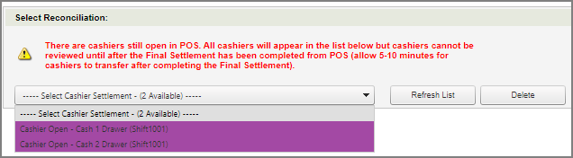

NOTE: After the authorization,  button will change to .

If there is an error after authorization, click  to unauthorize the settlement and start over.

NOTE: For the registers with **no cash** transaction like virtual registers (credit cards only), the system will close them automatically at 2:00am the next day. However, for whatever reason if there is **cash** payment, then the store will need to manually perform Cashier Settlement (follow Step 1-13). **Auto-close** only works for **non-cash registers**.

# Banking Deposit

Ensuring the stores cash is secured in the store safe after Cashier Settlement.

How to complete a Deposit

**Step 1.** From the Work Flow, select the ‘Banking Deposit’ task.

**Step 2.** Or from the Menu tab, navigate to the Financial – Banking Deposit Page.

 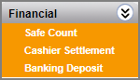

**2**

**1**

**Step 3.** Check that correct date is selected. 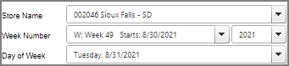

**3**

**Step 4.** On the ‘Banking Deposit’ tab, you will see 3 fields showing you the following amounts:

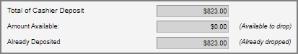

**4**

* **Total of Cashier Deposit:** The total cash amount that has been processed from the authorised Cashier Settlement’s, up to the current time of day.
* **Amount Available:** The total cash amount that is available to deposit into the safe.
* **Amount Dropped:** The total cash amount that has been deposited into the safe today.

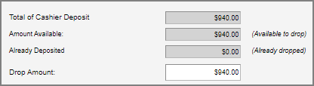**Step 5.** In **‘Drop Amount’**, enter the amount of cash you are about to deposit. The system will default ‘Drop Amount’ = ‘Amount Available’.

**5**

The store should only enter **ONE** deposit a day.

**Step 6.** Enter the deposit bag number in ‘Receipt No’. Post a deposit with a completed bank deposit slip and deposit bag number.

**Step 7.** Select ‘Confirm Drop’.



**7**

**6**

**Step 8.** You will then see the bank deposit listed showing the deposited amount.

**Step 9.** All cash collected from cashier closes (Cashier Settlement) will be listed below.

Before authorize banking, make sure ‘Deposited Amount’ = Total cashier close ‘Expected Deposited’.

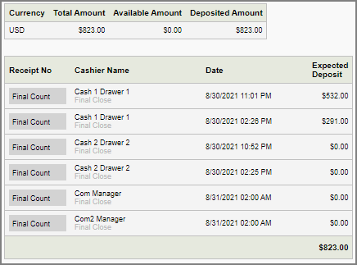

**9**

**8**

NOTE: On the Banking Deposit tab, after the authorization,  button will change to . However, this is a misleading because you **can not** un-authorize already authorized deposited banking. The ‘Release’ button is only used in the next tab, ‘Banking Summary’.

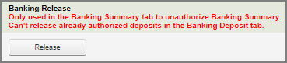

**NOTE:** Since you can’t un-authorize already authorized deposit, if you make a mistake entering incorrect deposit amount then you will need to enter another deposit to balance.

For example, if the total deposit is $600 but you entered $6,000 then you will need to make another deposit for negative the amount of **-**$5,400.

If the total deposit is $6,000 but you entered $600, then you will need to make another deposit for the amount of $5,400.

# Banking Summary

This screen allows the store manager the opportunity to review the summary of the day’s financial transactions.

How to review & release Deposit Banking Summary

**Step 1.** From the Work Flow, select the ‘Banking Close’ task. 

**2**

**1**

**Step 2.** Or from the Menu tab, navigate to the Financial – Banking Deposit Page – Banking Summary tab.

**Step 3.** 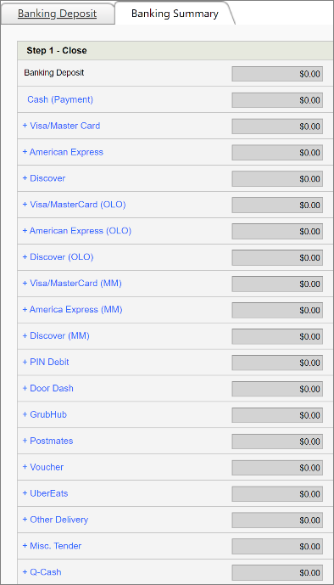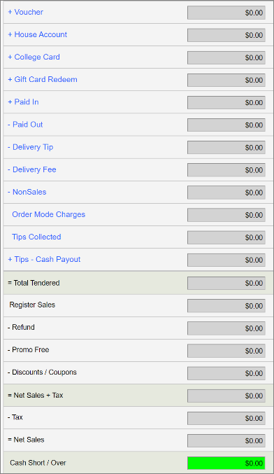The Banking Summary tab displays the deposit total plus consolidated information of financial data for the day.

**3**

**Step 4.** Verify ‘Tips Collected’ match ‘+ Tips – Cash Payout’. If they don’t, you need to release and modify the Cashier Settlement that it didn’t get entered on.

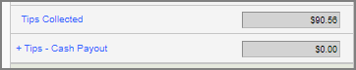

**4**

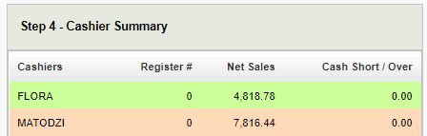

**5**

**Step 5.** Review ‘Step 4 - Cashier Summary’. This is a list of the Cashier Settlement’s. If all cashiers are showing highlighted in **green**, you can continue.

If you see this message below, please go back to your Cashier Settlement task and complete the cashiers that are not authorized yet.



**Step 6.** If there is a Cash Short/ Over amount that is +/- $10 you will need to enter in a Variance Explanation. An email notification will be sent to district managers.

 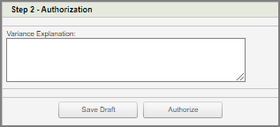

**6**

**7**

**Step 7.** Select ‘Authorize’ to authorize banking summary.

**NOTE:** If there is a significant variance, first ensure that

* All settlements have been closed and authorized.
* All sales cash has been recorded as deposits and authorized.