 | Standard Operating Procedures Best Practices for Inventory & Cash Management Work Flow

Work Flow Tasks:

Work Flow Steps
From the opening shift to closing shift, store manager’s log in and complete the tasks on the Work Flow as part of their normal store routine. The Work Flow should be completed each business day.

- When login to the system, the standard menu options will be presented as the default.  Click on the Work Flow tab.  - A list of work flow task will appear.  The Work Flow is the main way to access tasks. You can always click the Work Flow tab to return to the Work Flow.  The Menu is for occasional tasks or additional functionality. | 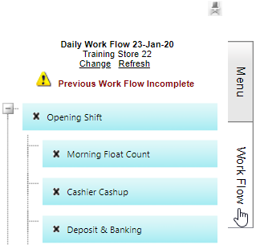  2  1
- Click the + and - symbol to expand the Work Flow to see tasks  - Click the pin symbol to make the workflow stay open or closed  - Click the Work Flow tab to always return to the Work Flow  - Click the Menu tab to access extra functionality | 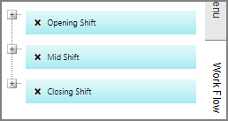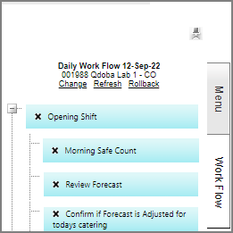  4  5  6  3
- The workflow is color coded to indicate activity:  - Green = Complete  - Dark Blue = In Progress  - Light blue = Not started | 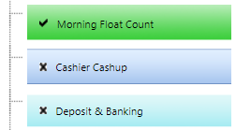  7
- Mouse over the task and ‘right click’ to change the task to: Complete = Task is finished. |   8
- This alert means the previous day’s Work Flow was not completed. | 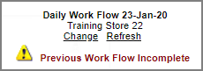  9
- Some of tasks are simply reminders and do not require the manager to use any functionality.  The reminders task items include the following and may vary from day to day. |   10
- When change the status of the validation task to ‘complete’, it will check that other dependant processes have been completed and if they have not, the task will prompt the manager to complete them before continuing. | 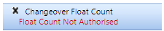  11  

