 | Standard Operating Procedures Best Practices for Inventory Transfer

Transfer Tasks:
- The requesting manager must call the sending store to request first.
- The requesting manager creates the transfer in Fourth.
- The receiving manager approves the transfer in Fourth as soon as the stock departs.

Request Transfer Steps
- Navigate to the Transfer – Request Transfer Page through the menu.  - The Mobile Request Transfer page will open with the list of stores that you can request transfer.  Click on the Select button to select the store. | 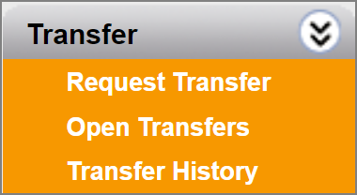  1  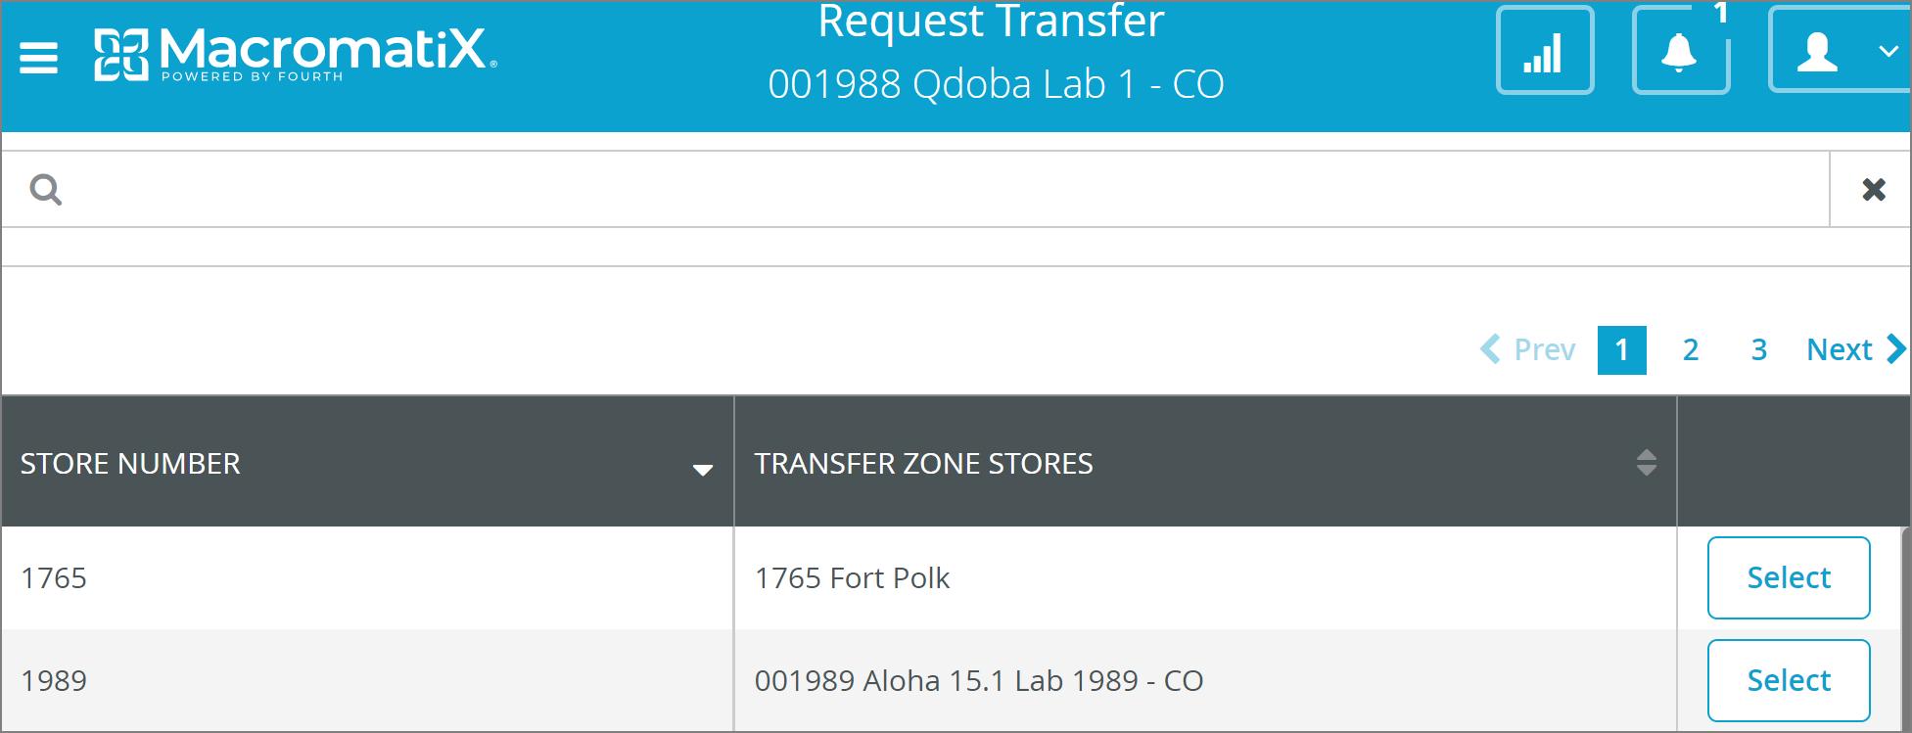  2
- Once you have selected a Restaurant, select the ‘+ ADD NEW ITEM(S)’ button. and a pop up will appear for you to search for items.  - Start typing in the item name and select the ‘SEARCH’ button.  - When the item appears in the search list, select it by ticking the box on the left and select | 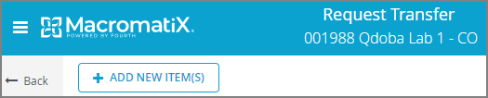  3  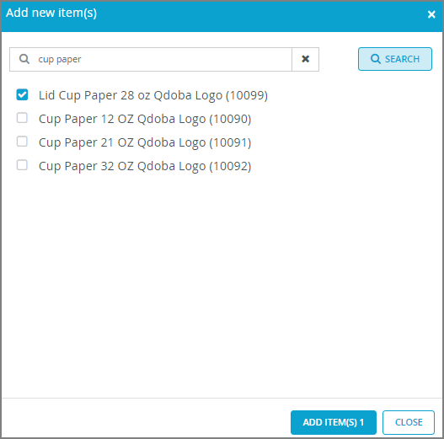  4  5
- The item will appear with field/s for you to enter in the quantities you want to request.  - If you no longer wish to request this item, you can click to delete the item.  If you wish to request multiple items, select and repeat steps 3-5. | 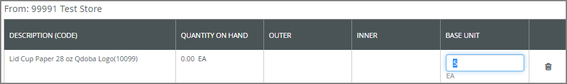  7  6
- To complete the transfer request, select the SUBMIT button.  - A confirmation pop up will briefly appear. |   8    9

Approve Transfer Steps
- Navigate to the Transfer – Open Transfer Page through the menu.  - The Mobile Open Transfer page will open with the list of stores that have requested transfers.  Click on the View button to select the store. | 1  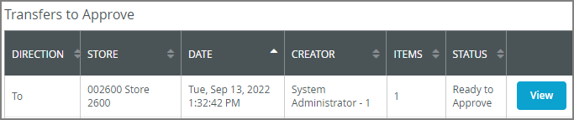  2
- It will show the transfer request details.  - By clicking on each item, you can see the item detail panel on the right. | 3  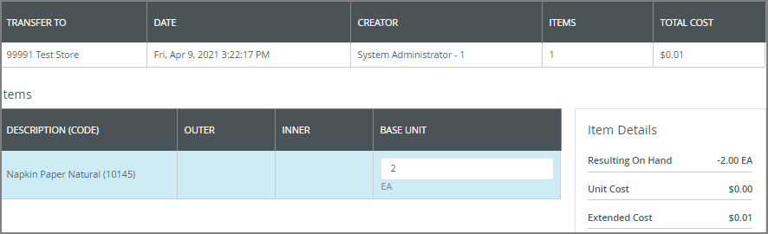  4
- Select the ACTIONS button to choose one of the following options:  - Approve  - Deny | 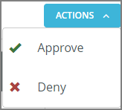  5  6
- Select ‘Approve’ to confirm you approve the stock to be sent from your store. Enter COST if it’s 0.  - Select the ‘CONTINUE’ button. | 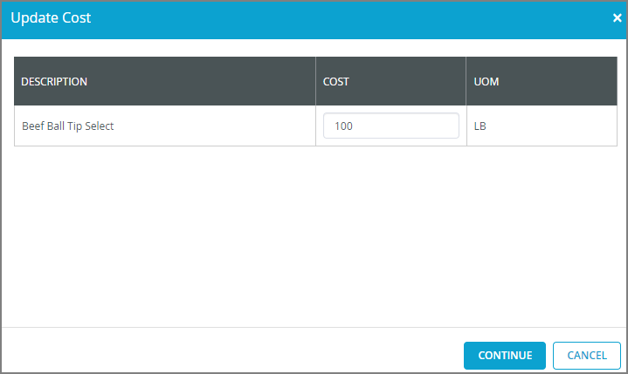  7
- A pop up will appear asking you to confirm.  If you select Approve, your inventory levels will decrease immediately. You must ensure the stock has been transferred or is going to be ASAP. | 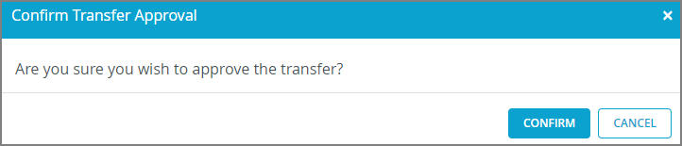  8
- Select ‘Deny’ option to deny the transfer being sent from your store. A pop up will appear asking you to enter a reason and confirm.  If you select Deny > your inventory levels will not change. The requesting store will get a notification alerting them that you denied their transfer request. | 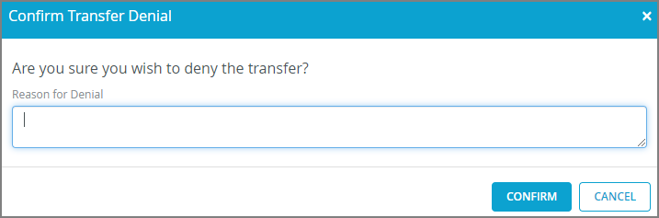  9

Transfer History Steps
- Navigate to the Transfer – Transfer History Page through the menu.  A list of transfers requests and approvals will appear here.  - Click ‘VIEW’ to see the transfer details. | 1  2  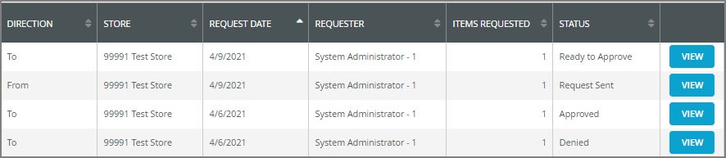
- It will show the transfer request details. | 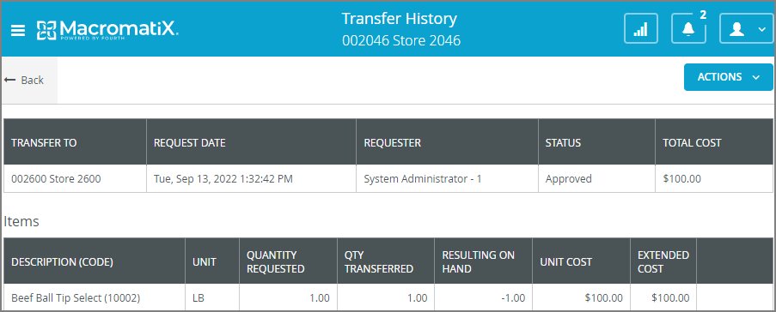  3

