 | Standard Operating Procedures Best Practices for Inventory Waste

Waste Tasks:

Waste Steps
Enter waste into the Fourth Waste module to ensure that any items which can no longer be used are removed from inventory – always ensuring that your inventory stock levels remain accurate.

- Navigate to the Waste – Waste.  - The Waste screen will appear and select ‘+ ADD NEW ITEM(S)’ to add items to waste. | 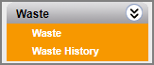  1  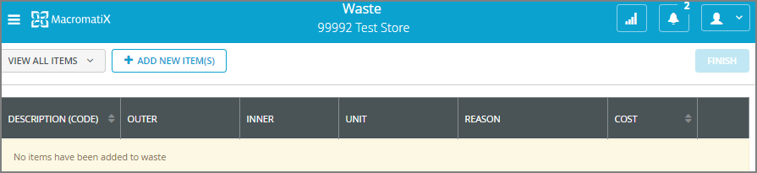  2
- Enter in the first few letters of the item in the open field and select ‘SEARCH’.  A list of items containing your search letters will appear from both the Inventory and Finished categories.  - Select the items you wish to record waste for by ticking the box on the left. | 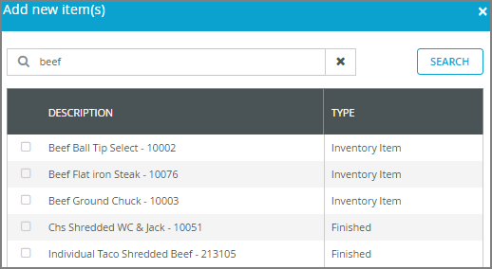  4  3
- Enter OUTER, INNER, or UNIT to waste.  - Select a reason for the waste by clicking on the ‘select reason’ field and choosing one from the drop-down.  - You can create a ‘Quick List’ of frequently wasted items that will help you quickly record waste next time. This Quick List of items will appear for you automatically on the front screen when you next log in. Each quick list is unique to each User.  - To save an item to your Quick List click the symbol on the far right of an item. When it turns blue this will save it to your list. To remove it from your Quick List, click the star symbol and it will turn grey again and not appear on your quick list.  - If you need to delete an item from being wasted click the trash can icon. | 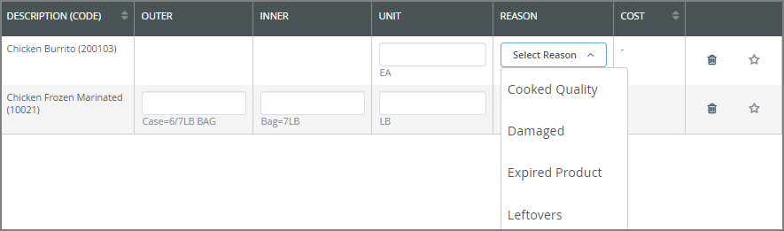  6  5  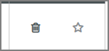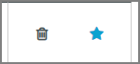  9  8  7
- When you are ready to confirm the waste, select ‘FINISH’. | 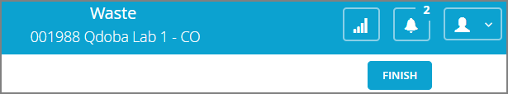  10
- Pop-up confirmation box will appear. To submit the waste, select ‘SUBMIT’. If will default to the current date and time. You can change it if needed. | 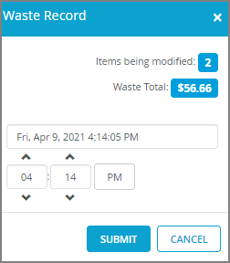  11

