 | Standard Operating Procedures Best Practices for Inventory Ordering

Scheduled Ordering Tasks:

Vendor Scheduled Ordering Steps
1. Vendor
2. Qdoba
3. Vendor
Send Scheduled Order
Place Order
Send order Confirmation
Send shipping confirmation

- Navigate to the Ordering – Scheduled Orders Page through the menu.  If the vendor sent the scheduled order, it will show on the Scheduled Page with the ‘STATUS’ set to ‘Pending’ and DELIVERY DATE and CUTOFF date & time.  The date on the calendar is the Order Date. | 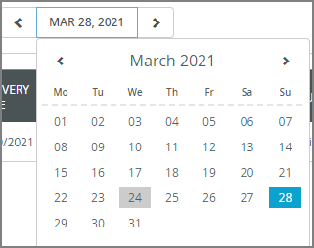  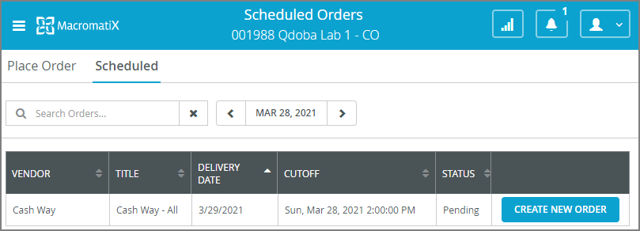  1
- If the store is ready to order, click the ‘CREATE NEW ORDER’ button.  - All the items for the vendor will display with suggested quantity to order based on the forecast projected figures.  - Enter QUANTITY for the desired items. | 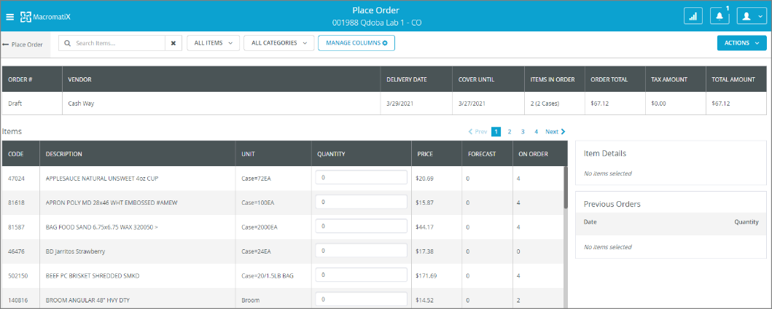  4  3  2
- Click the ‘ACTIONS’ pull-down and click ‘Save’ if the user wants to come back to place the order at a later time.  - The order STATUS will become ‘In Progress’. | 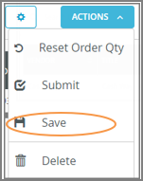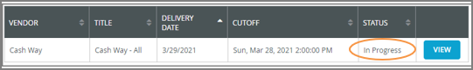  6  5
- Click the ‘VIEW’ button to continue editing the order. When complete, click the ‘Submit’ button to submit the order. The STATUS will become ‘Placed’. | 7  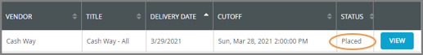
- If the vendor rejected the order for whatever the reason, they will send the reject order notification and the STATUS will become ‘Rejected’ which means this order is voided. | 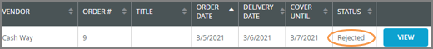  8
- After the vendor received the order, they will send the order confirmation and the STATUS will become ‘Vendor Confirmed’. | 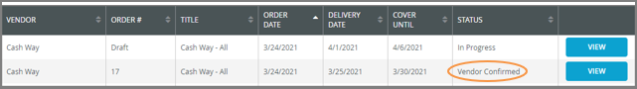  9

NOTE: Scheduled orders are imported from the vendor via the order data import. An alert notifies users of orders that were scheduled to be placed and are now overdue. If a user actions the alert, this does not mean the vendor has received the order, as it may be past their cut off.

Local Vendor Order Tasks:

Local Vendor Ordering Steps
It provides a tool for purchasing inventory from vendors for store operations. It is like the Scheduled Order function except the manager places an order whenever it is needed without a pre-determined schedule.

- Navigate to the Ordering – Place Order Page through the menu. | 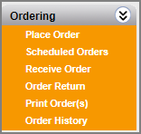  1
- Click on ‘+ADD ORDER’ button. | 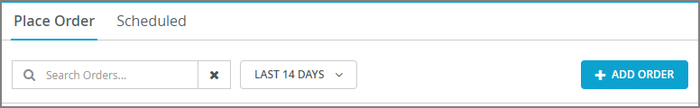  2
- Select the ‘Vendor’ from the drop-down list. | 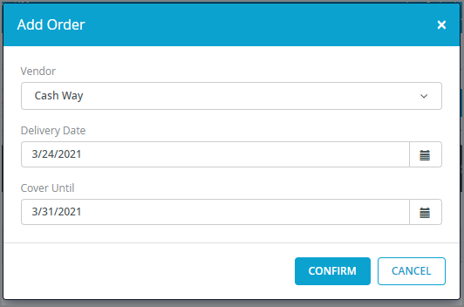  3
- Users can specify a default vendor, when creating new orders else it defaults to the first alphabetical vendor.  Users set the default vendor as the option that appears, at the top, in the 'Vendor' drop-down list.  To select the default vendor:  - Expand the drop-down list for the 'Vendor' field  - Click the 'Star' sign next to the desired selection. | 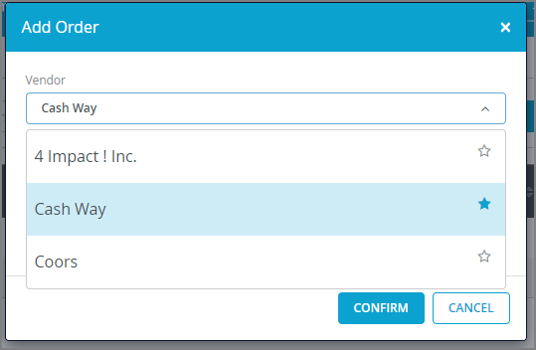  4
- Select ‘Delivery Date’ by clicking into the field to access the calendar pop-up. Past dates are not permitted.  - Select ‘Cover Until’ date.  ‘Cover Until’ is used to calculate order quantity.  - Click the ‘Confirm’ button. The Order Details page will display. | 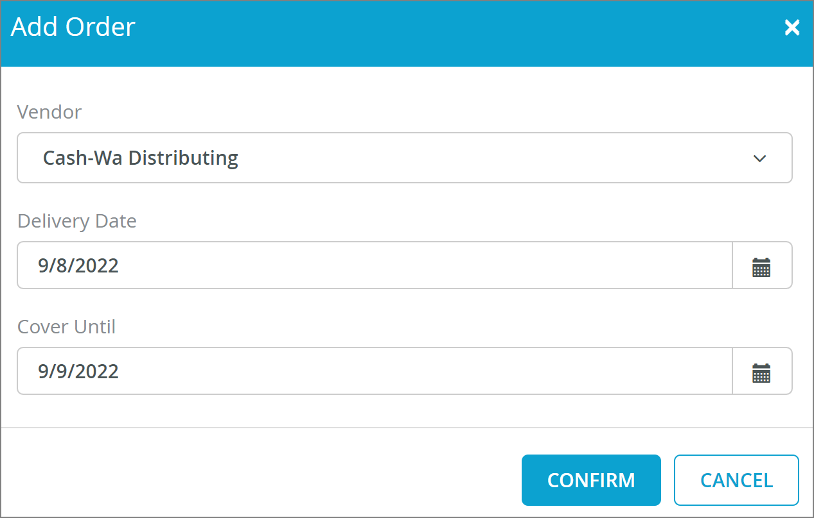  7  6  5
- After the vendor received the order, they will send the order confirmation and the STATUS will become ‘Vendor Confirmed’. | 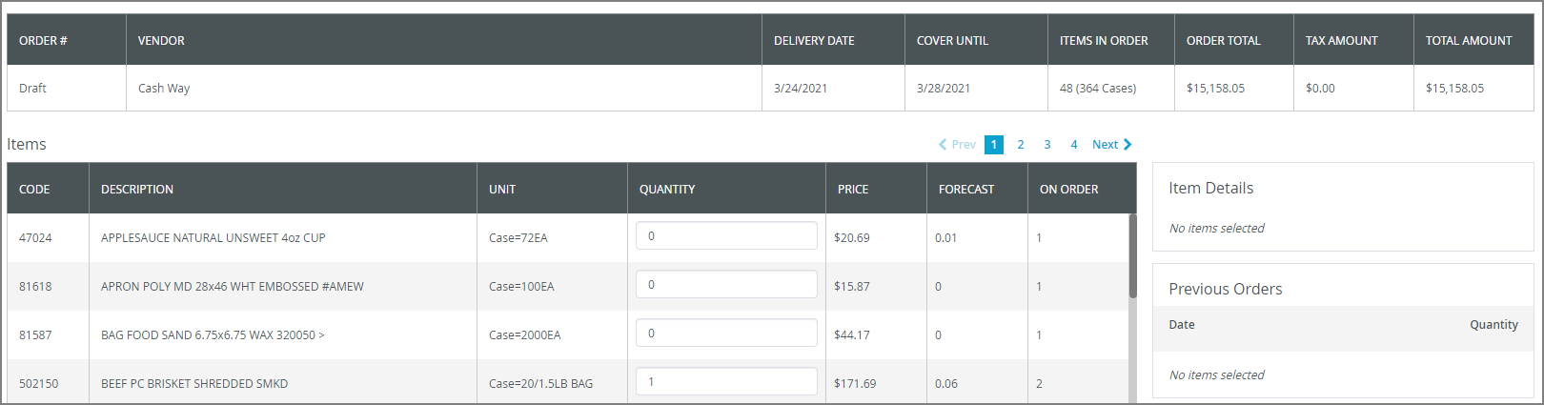  8
- If there are more than 50 items, then paging is triggered. |   9
- You can narrow down the selections by clicking ‘ALL CATEGORIES’ and selecting the desired category. | 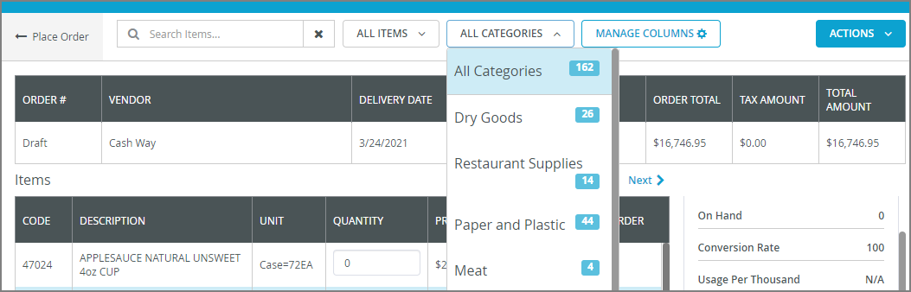  10
- A running count and order total is maintained as items are added. | 11
- Click the ‘ACTIONS’ pull-down and click ‘Submit’.  - Click ‘Save’ if the user wants to come back to place the order at a later time or ‘Delete’ to delete the order or ‘Reset Order Qty’ to reset all items in order quantity to 0. | 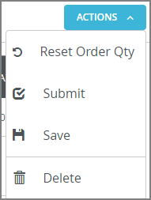  13  12
- Only check the ‘Auto-Receive Order’ box for once-off orders or orders that already received.  - Click the ‘CONFIRM’ button. The success message is displayed. | 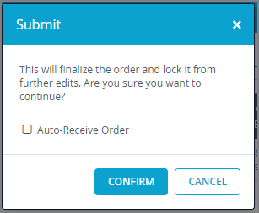  14  15

Receive Order Tasks:

Receive Order Steps
- Navigate to the Ordering – Receive Order Page through the menu. | 1
- The Receive Order Page will display with the orders that need to be received.  - Select the order on the Receive Order page and click the ‘RECEIVE’ button. | 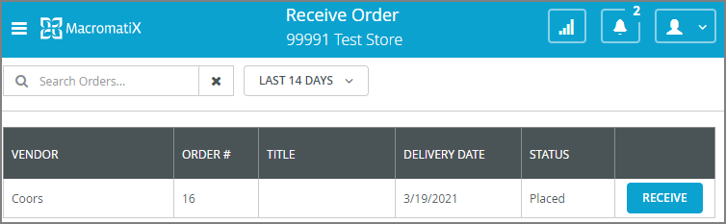  3  2
- The Notifications and Alerts are (as shown 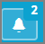) are for Overdue Order Receipt. It displays orders that are up to 14 days past their receive date.  - Click and the past orders will display. When the order is selected, it will take the user to the Receive Order Detail page. | 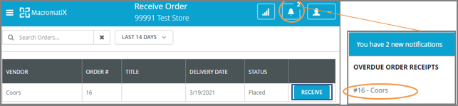  5  4
- The order detail will display. The ‘PRICE’, and ‘RECEIVED’ are default to the price and qty when placed the order. If the item received is less than the ordered qty, then the SHORTAGE REASON field will be enabled for the user to select the reason.  - You can add items as needed by clicking the ‘+ ADD ITEM(S)’ button. | 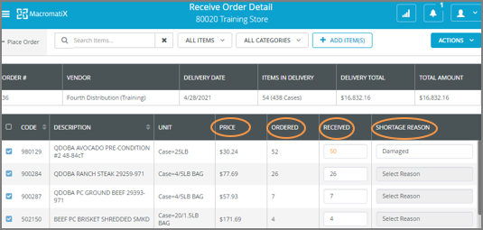  7  6
- Type the whole or partial vendor item description or vendor code and all the matched items will appear.  - Click on the item check-box to add to the order. | 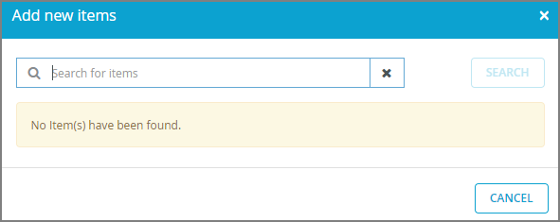  8  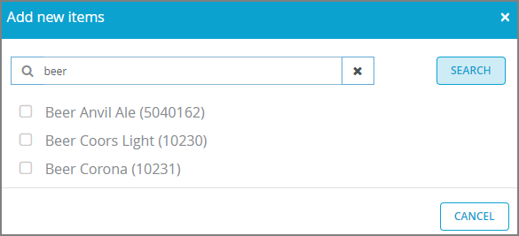  9
- Once done, select ‘ACTIONS’.  Click the ‘Receive Selected’ option. The ‘Finish Receive’ window will appear.  - Enter ‘Invoice Number’, ‘Receive Date’ (default to today’s date and time).  - Click ‘RECEIVE’ to complete the receive. | 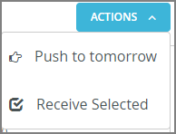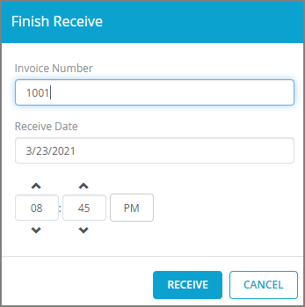  12  11  10

